**WHITE HORSE DENTAL PRACTICE**

We are planning to open our doors from Monday 15/6/2020, However we ask you **please do not call us unless you have extreme dental emergency/pain**, as you can appreciate we have a lot of a patients to contact and triage appropriately.

We are having limited and strict appointment times and infection control cleaning measures therefore we cannot see as many patients, as we would like.

**The dental practice doors will not be open to the public: Please see below the attendance instructions:**

**COME ALONE WHERE POSSIBLE**

**PLEASE ONLY BRING YOUR MOBILE PHONE AND PAYMENT METHOD (CARD PAYMENTS ONLY)**

We will call you **the day before** your app to triage you again in relation to COVID 19 symptoms.

**Please wait in your car/outside** and we will call you up to your appointment, please have your phone on you and update your details with us beforehand.

On entering the building please use the hand gel provided.

**Stay 2m apart from anyone in the building**

If you have a carer/parent to assist you, they must use the containers provided for storage of theses items and wear gloves and a mask whilst in the dental practice.

We have designated times for each appointment with strict infection control cleaning measures in place.

As you can appreciate time is precious, if you are late, we may not be able to see you or do the proposed treatment fully, and you may need to rebook another appointment, we also intend to run to time and will see you at the appointment time you are allocated.

**Please leave the building as soon as you have finished at White Horse Dental Practice.**

Please note in order to keep you all safe efficiently and effectively we have had to put extra measures and equipment in place.

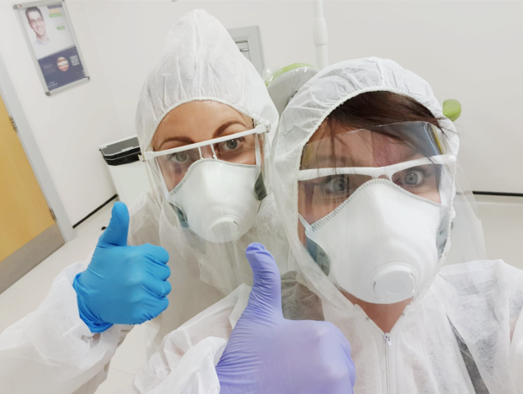

Treating you safely is our main priority. We have had to increase some charges, a contribution of £20 will be applied to all treatment appointments to cover some of the safety measures in place.